**INDUSTRIAL TRAINING REPORT**

**AMUSEMENT PARK WEBSITE**

Submitted in partial fulfillment of the

Requirements for the award of

**Industrial Training Certificate**



Submitted By:

Name: University Roll No.:

**SUSHMITHA R 1SI16IS056**

**PAVANA RAJU 1SI16IS039**

**NIRUPAMA 1SI16IS035**

**NAGATHEJU T V 1SI16IS034**

**GUNASHEELA B G 1SI16IS019**

**SUBMITTED TO:**

**Department of Information Science and Engineering**

**Siddaganga Institute of Technology, Tumakuru -572103**

**(An Autonomous Institution, Affiliated to VTU, Belagavi &Recognised by AICTE, New Delhi)**

**Department of Information Science and Engineering**

**Siddaganga Institute of Technology, Tumakuru -572103**

**(An Autonomous Institution, Affiliated to VTU, Belagavi &Recognised by AICTE, New Delhi)**



**CERTIFICATE**

This is to certify that Ms. **SUSHMITHA R(1SI16IS056),**Ms**.PAVANA RAJU(1SI16IS039),**Ms. **NIRUPAMA(1SI16IS035),** Ms. **NAGATHEJU T V(1SI16IS034),**Ms.**GUNASHEELA B G (1SI16IS019)** has partially completed / completed Industrial Training during the period from June 4, 2018 to July 14, 2018 in our Organization / Industry as a Partial fulfillment of Degree of Bachelor of Technology in Information Technology. We were trained in the field of Python, Django, Flask and Machine learning.

**Signature of GuideSignature of the Convener**

Amal Prasad Deepak Singh

**Training faculty Co-Founder, Monkfox**

**Signature of the HOD**

Dr. R Aparna

**Prof. and Head, Dept of ISE**

**DECLARATION**

I hereby declare that the Industrial Training Report entitled ("Amusement Park Website") is an authentic record of my own work as requirements of Industrial Training during the period from June 4, 2018 to July 14, 2018for the award of degree of B.E(Information science and engineering), Siddaganga Institute of Technology, Tumakuru, under the guidance of Mr. Amal Prasad and Mr. Deepak Singh.

Date: 11-07-2018 SUSHMITHA R

(1SI16IS056)

Date: 11-07-2018 PAVANA RAJU

(1SI16IS039)

Date: 11-07-2018 NIRUPAMA

(1SI16IS035)

Date: 11-07-2018 NAGATHEJU T V

(1SI16IS034)

Date: 11-07-2018 GUNASHEELA B G

(1SI16IS019)

**ACKNOWLEDGEMENT**

We express our sincere gratitude and salutations to His Holiness, **Dr.SreeSreeSreeShivakumaraSwamigalu,** Founder President, SSES, for being a constant source of inspiration in the course of study.

We are grateful to our beloved Director **Dr. M. N. Channabasappa,** for providing a congenial atmosphere and an ambience of learning in this institution.

We sincerely thank **Dr.Shivakumaraiah,** Principal, SIT, Tumakuru, for fostering an excellent academic environment with necessary facilities to achieve our goal.

We are grateful to our respected Head of the Department, **Dr. R Aparna** Professor and Head, Department of Information Science and Engineering, SIT, Tumakuru, for her continuous support and encouragement. Her suggestions and advice have been valuable to us.

We are thankful to**Mr. Amal Prasad,** for being our project guide who despitehis busy schedule was a constant source of motivation to us. Without his help and guidance, the project would not have been completed.

We also extend our gratitude to our parents and friends for their patience, untiring support and guidance throughout our academic journey.

Finally, we are thankful to all the faculty members and supporting staff of our department for their kind co-operation.

**Table of Contents**

**1. Introduction 6**

**2. Tools and Technology used7**

**3.Schema 8**

**4. Source code9**

**5. Snapshotsand Results54**

**7. Conclusions and Future Scope 61**

**8. Reference 62**

Introduction

* The project is about amusement park. Project contain details of facilities available, ambience of park i.e. different shows and games available in different areas and timings and also the details of resorts available in the park. All the details can be accessed easily so that it will aid a stranger and anybody can easily acquaint about the whole park.
* The project gives the details of the park timings, offers available for ticket booking, food available and it’scost, games and certain shows timings, resorts and details of it and also online ticket booking facility.
* If visitors lost any valuable things then they can acquaint, whether the lost thing is found or not through park’s website.

**TOOLS AND TECHNOLOGY USED**

* Flask Framework
* Python
* SQL
* HTML and CSS

**SCHEMA**

Sign-up

|  |  |  |  |  |
| --- | --- | --- | --- | --- |
| User id | Name | Email address | Phone number | Password |

Lost and found

|  |  |  |  |  |
| --- | --- | --- | --- | --- |
| Object id | Object name | ­­­Object type | Object color | Found date |

Ticket booking

|  |  |  |  |  |  |
| --- | --- | --- | --- | --- | --- |
| Complete name | Number of children | Number of adults | Number ofseniorcitizens | Mode of payment | Booking date |
| Month | Year | Food name | Quantity | Booking id |  |

**SOURCE CODE**

**new1.py**

from flask import Flask,render_template,request

import sqlite3 as sql

app=Flask(__name__)

@app.route('/')

def home():

return render_template('home2.html')

@app.route('/admin')

def admin():

return render_template('admin.html')

@app.route('/login')

def login():

return render_template('login.html')

@app.route('/userverify',methods=['POST','GET'])

def userverify():

if request.method=='POST':

uname=request.form['an']

pws=request.form['pws']

con=sql.connect("database.db")

con.row_factory=sql.Row

cur=con.cursor()

qry="SELECT * FROM myuser2 WHERE name='"+uname+"' and pass='"+pws+"'"

cur.execute(qry)

rows=cur.fetchall()

if (rows):

   return render_template('book2.html',rows=rows)

else:

msg="User name or Password is incorrect, make sure you have Signed Up before Login"

return render_template("result.html",msg=msg)

@app.route('/adminverify',methods=['POST','GET'])

def adminverify():

if request.method=='POST':

name=request.form['an']

pw=request.form['pws']

if(name=='admin' and pw=='admin'):

con=sql.connect("database.db")

con.row_factory=sql.Row

cur=con.cursor()

cur1=con.cursor()

cur2=con.cursor()

cur.execute("select count(*) from myuser2")

cur1.execute("select count(*) from pbookings")

cur2.execute("select count(*) from lost3")

c1=cur.fetchall()

c2=cur1.fetchall()

c3=cur2.fetchall()

return render_template('ahome.html',c1=c1,c2=c2,c3=c3)

else:

return render_template('home2.html')

@app.route('/adminhome')

def adminhome():

return render_template('ahome.html')

@app.route('/userdetails')

def userdetails():

con=sql.connect("database.db")

con.row_factory=sql.Row

cur=con.cursor()

cur.execute("select*from myuser2")

rows=cur.fetchall()

return render_template("listuser.html",rows=rows)

@app.route('/bookingdetails')

def bookingdetails():

con=sql.connect("database.db")

con.row_factory=sql.Row

cur=con.cursor()

cur.execute("select * from pbookings")

rows=cur.fetchall()

return render_template("bookinglist.html",rows=rows)

@app.route('/addfd')

def addfd():

return render_template('foods.html')

@app.route('/addgm')

def addgm():

return render_template('games.html')

@app.route('/addreg')

def addreg():

return render_template('register.html')

@app.route('/addres')

def addres():

return render_template('res.html')

@app.route('/addtic')

def addtic():

return render_template('tic.html')

@app.route('/addoff')

def addoffer():

return render_template('offer.html')

@app.route('/addtime')

def addtime():

return render_template('time.html')

@app.route('/adduser',methods=['POST','GET'])          #add record

def adduser():

if request.method=='POST':

try:

name=request.form['name']

email=request.form['email']

phone=request.form['phone']

pw=request.form['pw']

with sql.connect("database.db") as con:

cur=con.cursor()

qry="INSERT INTO myuser2(name,email,phone,pass) VALUES('"+ name +"','"+ email +"','"+ phone +"','"+ pw +"')"

cur.execute(qry)

con.commit()

msg="Record successfully added"

except:

con.rollback()

msg="error in insertion operation"

finally:

return render_template("home2.html",msg=msg)

con.close()

@app.route('/addbook',methods=['POST','GET'])          #add record

def addbook():

qry=''

msg=''

qry1=''

if request.method=='POST':

try:

bname=request.form['nm']

ch=request.form['ch']

ad=request.form['ad']

sen=request.form['sen']

dy=request.form['dy']

mn=request.form['mn']

yr=request.form['yr']

mp=request.form['mp']

fname=request.form['mysort']

qt=request.form['qt']

with sql.connect("database.db") as con:

cur=con.cursor()

qry1="INSERT INTO pbookings(name,child,adults,senior,mode,myday,month,year,food, quantity) VALUES('"+ bname +"',"+ ch + ","+ ad +","+ sen +",'"+ mp +"',"+ dy +","+ mn +","+ yr +",'"+ fname +"',"+ qt +")"

cur.execute(qry1)

con.commit()

msg="Record successfully added"

except:

con.rollback()

msg="error in insertion operation"

finally:

con.row_factory=sql.Row

cur=con.cursor()

cur.execute("select * from pbookings where rowid = (select max(rowid) from pbookings)")

rows=cur.fetchall();

return render_template("listorder1.html",rows=rows)

con.close()

else:

return render_template("home2.html")

@app.route('/deleteuser/<name>',methods=['POST','GET'])

def deleteuser(name):

if request.method=='GET':

try:

with sql.connect("database.db") as con:

cur=con.cursor()

qry="DELETE FROM myuser2 WHERE name='" + name + "'"

cur.execute(qry)

con.commit()

msg="Record deleted successfully"

except Exception as zd:

print(zd)

con.rollback()

msg="error in deletion operation"

finally:

return render_template("result1.html",msg=qry)

con.close()

@app.route('/deletebook/<name>',methods=['POST','GET'])

def deletebook(name):

if request.method=='GET':

try:

with sql.connect("database.db") as con:

cur=con.cursor()

cur.execute("DELETE FROM pbookings WHERE name='" + name + "'")

con.commit()

msg="Record deleted successfully"

except Exception as zd:

print(zd)

con.rollback()

msg="error in deletion operation"

finally:

return render_template("result1.html",msg=msg)

con.close()

@app.route('/addfound')

def addfound():

return render_template('foundform.html')

@app.route('/addfoundlist',methods=['POST','GET'])          #add record

def addfoundlist():

if request.method=='POST':

try:

obj=request.form['obj']

typ=request.form['type']

color=request.form['color']

date1=request.form['date1']

with sql.connect("database.db") as con:

cur=con.cursor()

qry="INSERT INTO lost3(object,type,color,date1) VALUES('"+ obj +"','"+ typ +"','"+ color +"','"+ date1 +"')"

cur.execute(qry)

con.commit()

msg="Record successfully added"

except:

con.rollback()

msg="error in insertion operation"

finally:

return render_template("ahome.html",msg=msg)

con.close()

@app.route('/founddetails')

def founddetails():

con=sql.connect("database.db")

con.row_factory=sql.Row

cur=con.cursor()

cur.execute("select * from lost3")

rows=cur.fetchall()

return render_template("foundlist.html",rows=rows)

@app.route('/lostverify',methods=['POST','GET'])

def lostverify():

if request.method=='POST':

oname=request.form['on']

otype=request.form['otype']

ocolour=request.form['ocolour']

con=sql.connect("database.db")

con.row_factory=sql.Row

cur=con.cursor()

qry="SELECT * FROM lost3 WHERE object='"+oname+"' and type='"+otype+"' and color='"+ocolour+"'"

cur.execute(qry)

rows=cur.fetchall()

if (rows):

msg="WE HAVE FOUND YOUR OBJECT PLEASE CONTACT US"

return render_template("result1.html",msg=msg)

else:

msg="WE HAVE NOT FOUND YOUR OBJECT, CHECK ONCE AGAIN AFTER 24 HOURS "

return render_template("result1.html",msg=msg)

@app.route('/addcmp')

def addcmp():

return render_template('login1.html')

@app.route('/userverify1',methods=['POST','GET'])

def userverify1():

if request.method=='POST':

uname=request.form['an']

pws=request.form['pws']

con=sql.connect("database.db")

con.row_factory=sql.Row

cur=con.cursor()

qry="SELECT * FROM myuser2 WHERE name='"+uname+"' and pass='"+pws+"'"

cur.execute(qry)

rows=cur.fetchall()

if (rows):

   return render_template('lostform.html',rows=rows)

else:

msg="User name or Password is incorrect, make sure you have Signed Up before Login"

return render_template("result.html",msg=msg)

@app.route('/lost')

def lost():

return render_template('lostform.html')

if __name__=='__main__':

app.run(debug=True)

admin.html

<html>

<body>

<link rel="stylesheet" href="{{url_for('static', filename='css/fm.css')}}">

<link rel="stylesheet" href="{{url_for('static', filename='css/bootstrap.min.css')}}">

<form action="{{url_for('adminverify')}}" method='POST'>

<div class="container">

<center><img src="/static/img/c1.jpg" width=800/><br>

<h3>Admin Login</h3>

<hr>

Admin Name<br>

<input type="text" name="an"/><br>

Password<br>

<input type="text" name="pws"/><br>

<input type="submit" name="submit"/><br>

<hr>

</form>

</center>

</body>

</html>

ahome.html

<!DOCTYPE html>

<html>

<head>

<meta charset="uff-8">

<title>Admin panel</title>

<style>

body {

background-image: url("../static/img/bb1.png");

padding-left:50px;

padding-right:50px;

}

h1{

background-color: pink;

}

</style>

</head>

<link rel="stylesheet" href="{{url_for('static', filename='css/bootstrap.min.css')}}">

<h5 align="right">

<div class="container">

<center><img src="/static/img/c1.jpg" width=800/><br></center>

<a href="/" class="btn btn-primary ml-2">Logout</h5></a><center>

<h1><br>ADMIN PANEL<br><br></h1>

<br><h2>WELCOME ADMIN</h2><br>

{% for r in c1 %}

<a href='/userdetails' class="btn btn-primary ml-2"><h5 align="middle">USER DETAILS <br>{{r[0]}}</h5></a>

{% endfor %}

<br><br>

{% for r in c2 %}

<a href="/bookingdetails" class="btn btn-primary ml-2"><h5 align="middle">BOOKING ORDER<br>{{r[0]}}</h5></a>

{% endfor %}

<br><br>

{% for r in c3 %}

<a href="/founddetails" class="btn btn-primary ml-2"><h5 align="middle">LOST AND FOUND LIST<br>{{r[0]}}</h5></a>

{% endfor %}

<br><br>

<a href="/addfound" class="btn btn-primary ml-2"><h6 align="middle">ADD FOUND OBJECTS</h6></a><br><br>

</center>

</div>

</body>

</html>

book2.html

<html>

<head>

<style>

body{

background-image: url("../static/img/Transparent.png");

background-size: 100%;

}

form{

background-color: grey;

color:white;

margin: 70px 400px;

padding: 0;

font-size: 20;

}

</style>

<link rel="stylesheet" href="{{url_for('static', filename='css/bootstrap.min.css')}}">

</head>

<body>

<center>

<img src="/static/img/c1.jpg" width=800/><br>

<h5 align="right">

<a href="/" class="btn btn-primary ml-2">LogOut</h5></a>

<h1>WELCOME &nbsp

{% for row in rows %}

{{row["name"]}}

{% endfor %}

</h1>

<form action="{{url_for('addbook')}}" method='POST'>

<h3>BOOKING INFORMATION</h3>

<div class="container">

<hr>

Complete  Name<br>

<input type="text" name="nm"/><br>

Number of children<br>

<input type="text" name="ch"/><br>

Number of adults<br>

<input type="text" name="ad"/><br>

Number of senior citizens<br>

<input type="text" name="sen"/><br>

Mode Of Payment<br>

<input type="text" name="mp"/><br>

Booking date<br>

<input type="text" name="dy"/><br>

Month<br>

<input type="text" name="mn"/><br>

Year<br>

<input type="text" name="yr"/><br>

Foodname<br>

<select name="mysort">

<option value= "none">None</option>

<option value= "south Indian Package">South Indian Package</option>

<option value= "North Indian Package">North Indian Package</option>

</select><br>

Quantity<br>

<input type="text" name="qt"/><br>

<input type="submit" name="submit"/><br>

<hr>

<small>Please do not leave any fields empty</small>

</form>

</center>

</body>

</html>

bookinglist.html

<!doctype html>

<html>

<head>

<style>

body {

background-image: url("../static/img/bb6.png");

border-image-width: 600;

border-image-width: 600;

padding-left:50px;

padding-right:50px;

}

</style>

</head>

<link rel="stylesheet" href="{{url_for('static', filename='css/bootstrap.min.css')}}">

<body>

<center>

<img src="/static/img/c1.jpg" width=800/><br></center>

<h5 align="right">

<a  href="/" class="btn btn-primary ml-2">Logout</a></h5>

<center><h1>BOOKING LIST</h1>

<table border=1>

<thead>

<td>Booking ID</td>

<td>Name</td>

<td>NO of adults </td>

<td>NO of children </td>

<td>NO of senior citizens </td>

<td>Date</td>

<td>Booking Price</td>

<td>Booking Tax</td>

<td>Booking Total amount</td>

<td>Mode of payment</td>

<td>Food name</td>

<td>Quantity</td>

<td>Food Price</td>

<td>Food Tax</td>

<td>Food Total Price</td>

<td>Total price</td>

<td>Delete</td>

</thead>

{%for row in rows %}

<tr>

<td>{{row["bid"]}}</td>

<td>{{row["name"]}}</td>

<td>{{row["adults"]}}</td>

<td>{{row["child"]}}</td>

<td>{{row["senior"]}}</td>

<td>{{row["myday"]}}/{{row["month"]}}/{{row["year"]}}</td>

<td>{{(row["adults"] * 1000+row["child"] * 700 +row["senior"] * 500)}}</td>

<td>{{((row["adults"] * 1000 +row["child"] * 700 +row["senior"] * 500)*8)/100 }}</td>

<td>{{(row["adults"] * 1000 +row["child"] * 700 +row["senior"] * 500)+(((row["adults"] * 1000 +row["child"] * 700 +row["senior"] * 500)*8)/100)}}</td>

<td>{{row["mode"]}}</td>

<td>{{row["food"]}}</td>

<td>{{row["quantity"]}}</td>

<td>{{row["quantity"]*300}}</td>

<td>{{((row["quantity"]*300)*6)/100}}</td>

<td>{{(row["quantity"]*300)+(((row["quantity"]*300)*6)/100)}}</td>

<td>{{(row["adults"] * 1000 +row["child"] * 700 +row["senior"] * 500)+(((row["adults"] * 1000 +row["child"] * 700 +row["senior"] * 500)*8)/100)+(((row["quantity"]*300)*6)/100)+(row["quantity"]*300)}}</td>

<td><a href="{{ url_for('deletebook', name=row.name) }}">delete</td></a>

</tr>

{% endfor %}

</table>

</center>

</body>

</html>

foods.html

<!DOCTYPE html>

<html>

<head>

<meta charset="utf-8">

<title>FOOD</title>

<style>

body {

background-image: url("../static/img/bb8.png");

border-image-width: 600;

padding-left:50px;

padding-right:50px;

}

h3{

background-color: skyblue;

}

</style>

</head>

<body>

<link rel="stylesheet" href="{{url_for('static', filename='css/bootstrap.min.css')}}">

<center><img src="/static/img/c1.jpg" width=800/><br></center>

<center><h2><a href="/addres" class="btn btn-primary ml-2"> Resorts</a>&nbsp

<a href="/addgm" class="btn btn-primary ml-2"> Games</a>&nbsp

<a href="/addtime" class="btn btn-primary ml-2">Park Timings</a>&nbsp

 <a href="/addtic" class="btn btn-primary ml-2">Tickets</a>&nbsp

<a href="/addoff" class="btn btn-primary ml-2"> Offers</a>&nbsp

 <a href="/addfd" class="btn btn-primary ml-2"> Food</a>&nbsp

 <a href="{{url_for('addcmp')}}" class="btn btn-primary ml-2"> Lost aything?</a>&nbsp

<a href="{{url_for('addreg')}}" class="btn btn-primary ml-2"> Sign Up</a>&nbsp

<a href="{{url_for('login')}}" class="btn btn-primary ml-2"> Login</a></h2>

<h3><b><u>FOOD</u></b></h3>

<img src="/static/img/food1.jpg"width=500/></center>

<br><b>JUST DON'T DROOL,EAT IT!!!!!!</b><br>

<br><h3>SOUTH INDIAN MEAL</h3><br>

<img src="/static/img/sim3.jpg"width=300/><br>

<b>BREAKFAST MENU</b><br>

<p>1.IDLY AND VADA</p>

<p>2.MASALA DOSA</p>

<P>3.UPMA</P>

<P>4.PONGAL</P>

<P>5.BISIBELEBATH</P>

<P>6.PULAV</P>

<img src="/static/img/ragimudhe.jpg."width=300/>

<br><b>LUNCH MENU</b><br>

<P>1.MEALS WITH CHAPATI</P>

<P>2.MEALS WITH RAGI BALL</P>

<br><b>SUPPER MENU</b><br>

<P>1.ANDHRA MEALS</P>

<P>2.MEALS WITH CHAPATI</P>

<P>3.MEALS WITH RAGI BALL</P>

<br><h3><b>NORTH INDIAN MEAL</b></h3><br>

<img src="/static/img/north3.jpg."width=300/>

<br><b>BREAKFAST MENU</b><br>

<p>1.GOBI PARATHA</p>

<p>2.CHOLE BHATURE</p>

<P>3.DAL KACHORI</P>

<P>4.POHA</P>

<img src="/static/img/north2.jpg."width=300/>

<br><b>LUNCH MENU</b><br>

<P>1.MEALS WITH ROTI</P>

<P>2.NON-VEG MEALS</P>

<br><b>SUPPER MENU</b><br>

<P>1.ANDHRA MEALS</P>

<P>2.MEALS WITH ROTI</P>

<P>3.VEG-BIRYANI AND KULCHA</p>

<b><h1>Any Food at 300 Rs</h1></b>

<footer><br><p align="right"><b>CONTACT  US AT 9876541320</footer>

</body>

</html>

foundform.html

<!doctype html>

<html>

<head>

<style>

body {

background-image: url("../static/img/bb9.png");

border-image-width: 600;

}

form{

background-color: black;

margin:70px 500px;

color:white;

}

</style>

<body>

<link rel="stylesheet" href="{{url_for('static', filename='css/bootstrap.min.css')}}">

<center><img src="/static/img/c1.jpg" width=800/><br></center>

<h5 align="right">

<br>

<a href="/" class="btn btn-primary ml-2">LogOut</h5></a>&nbsp

<center>

<form action="{{url_for('addfoundlist')}}" method='POST'>

<div class="container">

<h3>LOST AND FOUND OBJECT INFORMATION</h3>

<hr>

Object<br>

<input type="text" name="obj"/><br>

Company/Type<br>

<input type="text" name="type"/><br>

Colour<br>

<input type="text" name="color"/><br>

Found Date<br>

<input type="text" name="date1"/><br>

<input type="submit" name="submit"/><br>

<hr>

</div>

</center>

</form>

</body>

</html>

foundlist.html

<!doctype html>

<html>

<head>

<style>

body {

background-image: url("../static/img/bb9.png");

border-image-width: 600;

}

</style>

</head>

<link rel="stylesheet" href="{{url_for('static', filename='css/bootstrap.min.css')}}">

<body>

<h5 align="right">

<br>

<a href="/" class="btn btn-primary ml-2">LogOut</h5></a>

<center><img src="/static/img/c1.jpg" width=800/><br>

<h3>LOST AND FOUND OBJECT LIST</h3><br>

<table style="width:75%">

<tr>

<td>Object Id</td>

<td>Object </td>

<td>Company/Type</td>

<td>Colour</td>

<td>Date</td>

</tr>

{%for row in rows %}

<tr>

<td>{{row["lid"]}}</td>

<td>{{row["object"]}}</td>

<td>{{row["type"]}}</td>

<td>{{row["color"]}}</td>

<td>{{row["date1"]}}</td>

</tr>

{% endfor %}

</table></center>

</body>

</html>

games.html

<!DOCTYPE html>

<html>

<head>

<meta charset="uff-8">

<title>GAMES</title>

<style>

body {

background-image: url("../static/img/qbkls.png");

border-image-width: 600;

padding-left:50px;

padding-right:50px;

}

</style>

</head>

<link rel="stylesheet" href="{{url_for('static', filename='css/bootstrap.min.css')}}">

<center><img src="/static/img/c1.jpg" width=800/><br></center>

<center><h2><a href="/addres" class="btn btn-primary ml-2"> Resorts</a>&nbsp

<a href="/addgm" class="btn btn-primary ml-2"> Games</a>&nbsp

<a href="/addtime" class="btn btn-primary ml-2">Park Timings</a>&nbsp

 <a href="/addtic" class="btn btn-primary ml-2">Tickets</a>&nbsp

<a href="/addoff" class="btn btn-primary ml-2"> Offers</a>&nbsp

 <a href="/addfd" class="btn btn-primary ml-2"> Food</a>&nbsp

 <a href="{{url_for('addcmp')}}" class="btn btn-primary ml-2"> Lost aything?</a>&nbsp

<a href="{{url_for('addreg')}}" class="btn btn-primary ml-2"> Sign Up</a>&nbsp

<a href="{{url_for('login')}}" class="btn btn-primary ml-2"> Login</a></h2><br>

<h2><u>DRY GAMES</u></h2></center>

<h2>Roller Coaster</h2>

<p>it is a thrill game.The roller coaster will take you to the height of 40m from the ground.hence it is only preferred to folks of age above 15</P>

<img src="/static/img/rollercoaster2.jpg" width=400/>

<h2>Pirate ship</h2>

<p>This game is not for the weak hearted fellows.it will take you to an arc of 180 degree with sudden to and fro motion</P>

<img src="/static/img/pirateship.jpg" width=400/>

<h2>Net walk</h2>

<p>It is siutable for younger fellows but can also be played by the older ones.It will make you to walk through the net where maintaining balance is atmost important</P>

<img src="/static/img/nwalk.jpg" width=400/>

<h2>Sky wheel</h2>

<p>It is suitable for the people of age above 10.As name suggests the whole creature is like a wheel and it will be an enthralling ride with complete excitement</p>

<img src="/static/img/skywheel1.jpg" width=400/>

<h2>Dashing car</h2>

<p>it provides sublime happiness to the kids where they can happily clash with their friends with no harm.It is only for kids below 15 years of age</p>

<img src="/static/img/dashingcar1.jpg" width=400/>

<h2>Dungeon Ride</h2>

<p>It is a haunted house game.you will be taken inside a haunted house where will make you to fear.It's left for your strength to freak out amid this, just enjoy the haunted house</p>

<img src="/static/img/dungeonride.jpg" width=400/>

<h2>Cinemagic 3D</h2>

<p>It gives you the essence of virtual reality with HD-3D vedio,effective sound system and adjustable hydraulic seats.With the amazing 3D effect it takes you to the another visual world</p>

<img src="/static/img/3dcinema.jpg" width=400/>>

<h2>Magic Mushroom</h2>

<p>It is mainly for the kids below 15 years of age.They will get the essence of sitting on the horse and enjoying it's ride which will be circling them</p>

<img src="/static/img/mushroom.jpg" width=400/>

<h2>Mixer</h2>

<p>The capsule that you are locked in will move in all possible directions.This will make you to feel that you are locked in any blender.It's suitable for people of age above  15 years</p>

<img src="/static/img/maxres1.jpg" width=400/>

<h1><u>WET GAMES</u></h1>

<h2>Jungle Lagoon</h2>

<p>It's a family entertainer.Center of attraction for all kids.It provides you the sublime thrill in water</p>

<img src="/static/img/junglelagoon.jpg" width=400/>

<h2>Lazy River</h2>

<p>It is the funniest game.It is called as "lazy" because you will be easily drifted by water and you can just the enjoy the slow movement in water</p>

<img src="/static/img/lazyriver.jpg" width=400/>

<h2>Boomerang</h2>

<p>It is a water ride.Initially you will move in a closed tunnel and then suddenly you will be dropped from certain height and then which keeps on moving to and fro</p>

<img src="/static/img/boomerang.jpg" width=400/>>

<h2>Fun Racers</h2>

<p>It is a water slide where you will be lying down on a rubber mat.You will come downward by sliding and suddenly splash into water</p>

<img src="/static/img/funracers1.jpg" width=400/>

<h2>Twisters</h2>

<p>The capsule that you are locked in will move in all possible directions.This will make you to feel that you are locked in any blender.It's suitable for people of age above  15 years</p>

<img src="/static/img/twisters.jpg" width=400/>

<h2>Wave Pool</h2>

<p>The timings for wave pool is from 3.30 pm to 4.30 pm.It will give you the essence of playing in seas along with waves.As you move forward the depth of pool increases</p>

<img src="/static/img/wavepool.jpg" width=400/>>

<h2>Rain Disco</h2>

<p>It is a indoor like game.As name suggests warm water will be showered with music and flickering laser ligths.It is a wild game where you can dance with warm water and music</p>

<img src="/static/img/raindisco.jpg" width=400/>

<h2>Kayaking</h2>

<p>It is just moving across the water.It will give you the boating experience.The safety jacket along with oars will be provided to you to ensure your safety and depth of the water will not be much.</p>

<img src="/static/img/kayaking.jpg" width=400/>

<h2>Wavy And Vertical Fall</h2>

<p>It is similar to the twisters but there will be no loops to slow you down.It will be too steepy and at the end you will come and splash the water with maximum speed</p>

<img src="/static/img/wv.jpg" width=400/>

<footer><br><p align="right"><b>CONTACT  US AT 9876541320</footer>

</body>

</html>

home2.html

<!DOCTYPE html>

<html>

<head>

<meta charset="utf-8">

<title>AMUSEMENT PARK</title>

<style>

h1{

background-color: pink;

}

h2{

background-color: grey;

color: white;

}

body {

background-image: url("../static/img/pic1.jpg");

border-image-width: 1000px;

}

</style>

<link rel="stylesheet" href="{{url_for('static', filename='css/style.css')}}">

<link rel="stylesheet" href="{{url_for('static', filename='css/bootstrap.min.css')}}">

</head>

<div class="container">

<center>

<img src="/static/img/c1.jpg" width=800/><br>

</center>

<center><h2><a href="/addres" class="btn btn-primary ml-2"> Resorts</a>&nbsp

<a href="/addgm" class="btn btn-primary ml-2"> Games</a>&nbsp

<a href="/addtime" class="btn btn-primary ml-2">Park Timings</a>&nbsp

 <a href="/addtic" class="btn btn-primary ml-2">Tickets</a>&nbsp

<a href="/addoff" class="btn btn-primary ml-2"> Offers</a>&nbsp

 <a href="/addfd" class="btn btn-primary ml-2"> Food</a>&nbsp

 <a href="{{url_for('addcmp')}}" class="btn btn-primary ml-2"> Lost aything?</a>&nbsp

<a href="{{url_for('addreg')}}" class="btn btn-primary ml-2"> Sign Up</a>&nbsp

<a href="{{url_for('login')}}" class="btn btn-primary ml-2"> Login</a></h2></center>

<div id="slider">

<p>

<figure>

<img src="/static/img/sd.jpg" width=100 height=600/><br>

<img src="/static/img/3dcinema.jpg" width=100 height=600/><br>

<img src="/static/img/park.jpg" width=100 height=600/><br>

<img src="/static/img/dungeonride.jpg" width=100 height=600/><br>

<img src="/static/img/twisters.jpg" width=100 height=600 /><br>

</figure>

</div>

   </div>

   <footer><br><p align="right"><b>CONTACT  US AT 9876541320</footer>

</body>

</html>

listorder1.html

<!doctype html>

<html>

<head>

<style>

body {

background-image: url("../static/img/bb9.png");

border-image-width: 600;

}

</style>

</head>

<body>

<link rel="stylesheet" href="{{url_for('static', filename='css/bootstrap.min.css')}}">

<center><img src="/static/img/c1.jpg" width=800/><br></center>

<h5 align="right">

<a href="/" class="btn btn-primary ml-2">LogOut</h5></a><center>

<h1> BILL </h1>

<table>

<thead>

<td></td>

<td></td>

</thead>

{%for row in rows %}

<tr>

<td>Booking ID</td><td> :{{row["bid"]}}</td></tr>

<td>Name &nbsp </td>     <td> :{{row["name"]}}</td></tr>

<tr><td>NO of adults &nbsp  </td><td> :{{row["adults"]}}</td></tr>

<tr><td>NO of children  &nbsp </td><td> :{{row["child"]}}</td></tr>

<tr><td>NO of senior citizens&nbsp</td>    <td> :{{row["senior"]}}</td></tr>

<tr><td>Date &nbsp                </td><td> :{{row["myday"]}}/{{row["month"]}}/{{row["year"]}}</td></tr>

<tr><td>Ticket price &nbsp </td>    <td> :{{(row["adults"] * 1000+row["child"] * 700 +row["senior"] * 500)}}</td></tr>

<tr><td>Ticket Tax    &nbsp </td><td>     :{{((row["adults"] * 1000 +row["child"] * 700 +row["senior"] * 500)*8)/100 }}</td></tr>

<tr><td>Ticket Total Amount &nbsp</td>    <td> :{{(row["adults"] * 1000 +row["child"] * 700 +row["senior"] * 500)+(((row["adults"] * 1000 +row["child"] * 700 +row["senior"] * 500)*8)/100)}}</td></tr>

<tr><td>Mode of Payment   &nbsp </td><td> :{{row["mode"]}}</td></tr>

<tr><td>Food Package Name &nbsp  </td><td> :{{row["food"]}}</td></tr>

<tr><td>Quantity     &nbsp </td><td>       :{{row["quantity"]}}</td></tr>

<tr><td>Food Price   &nbsp </td><td>       :{{row["quantity"]*300}}</td></tr>

<tr><td>Food Tax     &nbsp </td><td>       :{{((row["quantity"]*300)*6)/100}}</td></tr>

<tr><td>Food Total price &nbsp </td>    <td> :{{row["quantity"]*300+(((row["quantity"]*300)*6)/100)}} </td></tr>

<tr><td>Grand Total     &nbsp </td><td> :{{(row["adults"] * 1000 +row["child"] * 700 +row["senior"] * 500)+(((row["adults"] * 1000 +row["child"] * 700 +row["senior"] * 500)*8)/100)+(((row["quantity"]*300)*6)/100)+(row["quantity"]*300)}}</td></tr>

{% endfor %}

<br>

</table>

</center>

<footer><br><p align="right"><b>CONTACT  US AT 9876541320</footer>

</body>

</html>

listuser.html

<!doctype html>

<html>

<head>

<style>

body {

background-image: url("../static/img/bb9.png");

border-image-width: 600;

border-image-width: 600;

padding-left:50px;

padding-right:50px;

}

</style>

</head>

<link rel="stylesheet" href="{{url_for('static', filename='css/bootstrap.min.css')}}">

<body>

<center><img src="/static/img/c1.jpg" width=800/><br>

<h5 align="right">

<a href="/" class="btn btn-primary ml-2">Logout</h5></a>

<table style="width:75%">

<tr>

<td><B>User Id</td>

<td><B>User Name</td>

<td><B>User Email</td>

<td><B>User Phone Number</td>

<!--<td><B>Delete</td> -->

</tr>

{%for row in rows %}

<tr>

<td>{{row["id"]}}</td>

<td>{{row["name"]}}</td>

<td>{{row["email"]}}</td>

<td>{{row["phone"]}}</td>

<!--<td><a href="{{ url_for('deleteuser', name=row.name) }} ">delete</td></a-->

</tr>

{% endfor %}

</table></center>

</body>

</html>

login.html

<html>

<head>

<style>

body{

background-image: url("../static/img/sd1.jpg");

}

form{

background-color: black;

margin: 50px 550px;

color: white;

}

</style>

</head>

<body>

<link rel="stylesheet" href="{{url_for('static', filename='css/bootstrap.min.css')}}">

<center><img src="/static/img/c1.jpg" width=800/><br>

<h2><a href="/addres" class="btn btn-primary ml-2"> Resorts</a>&nbsp

<a href="/addgm" class="btn btn-primary ml-2"> Games</a>&nbsp

<a href="/addtime" class="btn btn-primary ml-2">Park Timings</a>&nbsp

 <a href="/addtic" class="btn btn-primary ml-2">Tickets</a>&nbsp

<a href="/addoff" class="btn btn-primary ml-2"> Offers</a>&nbsp

 <a href="/addfd" class="btn btn-primary ml-2"> Food</a>&nbsp

 <a href="{{url_for('addcmp')}}" class="btn btn-primary ml-2"> Lost aything?</a>&nbsp

<a href="{{url_for('addreg')}}" class="btn btn-primary ml-2"> Sign Up</a>&nbsp

<a href="{{url_for('login')}}" class="btn btn-primary ml-2"> Login</a></h2>

<center>

<form action="{{url_for('userverify')}}" method='POST'>

<div class="container">

<br>

<h3>User Login</h3>

<br>

User Name<br>

<input type="text" name="an"/><br><br>

Password<br>

<input type="text" name="pws"/><br><br>

<input type="submit" name="submit"/><br><br>

</form>

</center>

<h5 align="middle">

<a href="/admin" class="btn btn-primary ml-2">Login as admin</h5></a>

</div>

<footer><br><p align="right"><b>CONTACT  US AT 9876541320</footer>

</body>

</html>

login1.html

<html>

<head>

<style>

body{

background-image: url("../static/img/sd1.jpg");

}

form{

background-color: black;

margin: 50px 550px;

color: white;

}

</style>

</head>

<body>

<link rel="stylesheet" href="{{url_for('static', filename='css/bootstrap.min.css')}}">

<center><img src="/static/img/c1.jpg" width=800/><br>

<h2><a href="/addres" class="btn btn-primary ml-2"> Resorts</a>&nbsp

<a href="/addgm" class="btn btn-primary ml-2"> Games</a>&nbsp

<a href="/addtime" class="btn btn-primary ml-2">Park Timings</a>&nbsp

 <a href="/addtic" class="btn btn-primary ml-2">Tickets</a>&nbsp

<a href="/addoff" class="btn btn-primary ml-2"> Offers</a>&nbsp

 <a href="/addfd" class="btn btn-primary ml-2"> Food</a>&nbsp

<a href="{{url_for('addreg')}}" class="btn btn-primary ml-2"> Sign Up</a>&nbsp

<a href="{{url_for('login')}}" class="btn btn-primary ml-2"> Login</a></h2>

<center>

<form action="{{url_for('userverify1')}}" method='POST'>

<div class="container">

<br>

<h3>User Login</h3>

<br>

User Name<br>

<input type="text" name="an"/><br><br>

Password<br>

<input type="text" name="pws"/><br><br>

<input type="submit" name="submit"/><br><br>

</form>

</center>

</div>

<footer><br><p align="right"><b>CONTACT  US AT 9876541320</footer>

</body>

</html>

lostform.html

<html>

<head>

<style>

body {

background-image: url("../static/img/bb.png");

border-image-width: 600;

}

form{

background-color: black;

margin:70px 500px;

color:white;

}

</style>

<body>

<link rel="stylesheet" href="{{url_for('static', filename='css/bootstrap.min.css')}}">

<center><img src="/static/img/c1.jpg" width=800/><br>

<h2><a href="/addres" class="btn btn-primary ml-2"> Resorts</a>&nbsp

<a href="/addgm" class="btn btn-primary ml-2"> Games</a>&nbsp

<a href="/addtime" class="btn btn-primary ml-2">Park Timings</a>&nbsp

 <a href="/addtic" class="btn btn-primary ml-2">Tickets</a>&nbsp

<a href="/addoff" class="btn btn-primary ml-2"> Offers</a>&nbsp

 <a href="/addfd" class="btn btn-primary ml-2"> Food</a>&nbsp

<a href="{{url_for('addreg')}}" class="btn btn-primary ml-2"> Sign Up</a>&nbsp

<a href="{{url_for('login')}}" class="btn btn-primary ml-2"> Login</a></h2>

</center>

<br>

<h5 align="right">

<a href="/" class="btn btn-primary ml-2">LogOut</a>&nbsp &nbsp &nbsp &nbsp</h5>

<center>

<form action="{{url_for('lostverify')}}" method='POST'>

<div class="container">

<h3>LOST OBJECT INFORMATION</h3>

<hr>

Object<br>

<input type="text" name="on"/><br>

Company/Type<br>

<input type="text" name="otype"/><br>

Colour<br>

<input type="text" name="ocolour"/><br>

<input type="submit" name="submit"/><br>

<hr>

</div>

</center>

</form>

<footer><br><p align="right"><b>CONTACT  US AT 9876541320</footer>

</body>

</html>

offer.html

<!DOCTYPE html>

<html>

<head>

<meta charset="utf-8">

<title>OFFERS</title>

<style>

h3{

background-color: skyblue;

}

body {

background-image: url("../static/img/bb8.png");

border-image-width: 600;

padding-left:50px;

padding-right:50px;

}

</style>

</head>

<body>

<link rel="stylesheet" href="{{url_for('static', filename='css/bootstrap.min.css')}}">

<center><img src="/static/img/c1.jpg" width=800/><br></center>

<center><h2><a href="/addres" class="btn btn-primary ml-2"> Resorts</a>&nbsp

<a href="/addgm" class="btn btn-primary ml-2"> Games</a>&nbsp

<a href="/addtime" class="btn btn-primary ml-2">Park Timings</a>&nbsp

 <a href="/addtic" class="btn btn-primary ml-2">Tickets</a>&nbsp

<a href="/addoff" class="btn btn-primary ml-2"> Offers</a>&nbsp

 <a href="/addfd" class="btn btn-primary ml-2"> Food</a>&nbsp

 <a href="{{url_for('addcmp')}}" class="btn btn-primary ml-2"> Lost aything?</a>&nbsp

<a href="{{url_for('addreg')}}" class="btn btn-primary ml-2"> Sign Up</a>&nbsp

<a href="{{url_for('login')}}" class="btn btn-primary ml-2"> Login</a></h2>

<h3><b>OFFERS<b></h3>

<img src="/static/img/spoffer.jpg" width=500/></center>

<B><p>1.College students:show your ID card and get flat 30% off on ticket prices.</p>

<img src="/static/img/offer30.png" width=200/>

<p>2.Flat 20% off on packages with tickets + car travel + meals only applied in offline.</p>

<img src="/static/img/offer20.jpg" width=200/>

<p>3.Get a children ticket for free on purchasing  two adult ticket in offline,Children age should be below 12 years.</p>

<img src="/static/img/child.jpg" width=200/>

<p>4.Buy 4 tickets and get one free.</p></B>

<img src="/static/img/offersnew.png" width=200/>

</body>

</html>

register.html

<html>

<head>

<style>

body {

background-image: url("../static/img/bb.png");

border-image-width: 600;

}

form{

background-color: black;

margin:70px 500px;

color:white;

}

</style>

<body>

<link rel="stylesheet" href="{{url_for('static', filename='css/bootstrap.min.css')}}">

<center><img src="/static/img/c1.jpg" width=800/><br>

<h2><a href="/addres" class="btn btn-primary ml-2"> Resorts</a>&nbsp

<a href="/addgm" class="btn btn-primary ml-2"> Games</a>&nbsp

<a href="/addtime" class="btn btn-primary ml-2">Park Timings</a>&nbsp

 <a href="/addtic" class="btn btn-primary ml-2">Tickets</a>&nbsp

<a href="/addoff" class="btn btn-primary ml-2"> Offers</a>&nbsp

 <a href="/addfd" class="btn btn-primary ml-2"> Food</a>&nbsp

 <a href="{{url_for('addcmp')}}" class="btn btn-primary ml-2"> Lost aything?</a>&nbsp

<a href="{{url_for('addreg')}}" class="btn btn-primary ml-2"> Sign Up</a>&nbsp

<a href="{{url_for('login')}}" class="btn btn-primary ml-2"> Login</a></h2>

<center>

<form action="{{url_for('adduser')}}" method='POST'>

<div class="container">

<h3>USER INFORMATION</h3>

<hr>

Name<br>

<input type="text" name="name"/><br>

Email<br>

<input type="text" name="email"/><br>

Phone Number<br>

<input type="text" name="phone"/><br>

Password<br>

<input type="text" name="pw"/><br>

<input type="submit" name="submit"/><br>

<hr>

</div>

</center>

</form>

<footer><br><p align="right"><b>CONTACT  US AT 9876541320</footer>

</body>

</html>

res.html

<!DOCTYPE html>

<html>

<head>

<meta charset="uff-8">

<title>Resorts</title>

<style>

body {

background-image: url("../static/img/bb8.png");

border-image-width: 600;

padding-left:50px;

padding-right:50px;

}

h3{

background-color: skyblue;

}

h4{

background-color:pink;

}

</style>

</head>

<body>

<link rel="stylesheet" href="{{url_for('static', filename='css/bootstrap.min.css')}}">

<center><img src="/static/img/c1.jpg" width=800/><br></center>

<center><h2><a href="/addres" class="btn btn-primary ml-2"> Resorts</a>&nbsp

<a href="/addgm" class="btn btn-primary ml-2"> Games</a>&nbsp

<a href="/addtime" class="btn btn-primary ml-2">Park Timings</a>&nbsp

 <a href="/addtic" class="btn btn-primary ml-2">Tickets</a>&nbsp

<a href="/addoff" class="btn btn-primary ml-2"> Offers</a>&nbsp

 <a href="/addfd" class="btn btn-primary ml-2"> Food</a>&nbsp

 <a href="{{url_for('addcmp')}}" class="btn btn-primary ml-2"> Lost aything?</a>&nbsp

 <a href="{{url_for('addreg')}}" class="btn btn-primary ml-2"> Sign Up</a>&nbsp

<a href="{{url_for('login')}}" class="btn btn-primary ml-2"> Login</a></h2><br><br>

<h3>RESORTS</h3></center>

<h4>The Red Earth Resort</h4><br>

<img src="/static/img/resort3.jpg" width=400/><br>

<b>lavishness will not bring you tranquility</b>

<p>One of the finest resorts which will comfort you like home.You will enjoy the serenity and beauty of the resort and the nature around it.if you are really a nature lover and looking forward to stay in such a place then "the red earth" is the best.the cost of staying here per day per person is 5,000.The facilities provided are breakfast,lunch and supper which will be available in both north and south indian style.</p><br>

<h2>The Oberoi</h2><br>

<img src="/static/img/resort1.jpg" width=400/><br>

<b>luxury comforts you</b>

<p>one of the luxurious resorts which will comfort you more than a home.your solitude will not be touched here forever.The best place to spend your vacation with your loved ones.the cost of staying here perday per person will be 20,000.The breakfast,lunch,supper will be provided in north and south indian style,caribbean,chinese,french and italian styles.The other facilities are children's play area,swimming pool,conference room.</p>

<footer><br><p align="right"><b>CONTACT  US AT 9876541320</footer>

</body>

</html>

result.html

<!doctype html>

<html>

<head>

<style>

body {

background-image: url("../static/img/bb9.png");

border-image-width: 600;

}

h1{

margin: 200px 400px

}

</style>

</head>

<body>

<link rel="stylesheet" href="{{url_for('static', filename='css/bootstrap.min.css')}}">

<center><br><br><h1>{{msg}}</h1><br></center>

<div class="container">

<h2 align="right"><a href="/addreg" class="btn btn-primary ml-2">Sign Up</h2></a>

</div>

<footer><br><p align="right"><b>CONTACT  US AT 9876541320</footer>

</body>

</html>

result1.html

<!doctype html>

<html>

<head>

<style>

body {

background-image: url("../static/img/bb9.png");

border-image-width: 600;

}

h1{

margin: 200px 400px

}

</style>

</head>

<body>

<link rel="stylesheet" href="{{url_for('static', filename='css/bootstrap.min.css')}}">

<b><h1><center><br><br><br>{{msg}}</center></h1></b>

<div class="container">

<h5 align="right"><a href="/" class="btn btn-primary ml-2">Back</h5></a>

</div>

</body>

</html>

tic.html

<!DOCTYPE html>

<html>

<head>

<meta charset="utf-8">

<title>Tickets</title>

<style>

h3{

background-color: skyblue;

}

h4{

background-color: black;

color: white;

}

body {

background-image: url("../static/img/bb6.png");

border-image-width: 600;

padding-left:50px;

padding-right:50px;

}

</style>

</head>

<body>

<link rel="stylesheet" href="{{url_for('static', filename='css/bootstrap.min.css')}}">

<center><img src="/static/img/c1.jpg" width=800/><br></center>

<center><h2><a href="/addres" class="btn btn-primary ml-2"> Resorts</a>&nbsp

<a href="/addgm" class="btn btn-primary ml-2"> Games</a>&nbsp

<a href="/addtime" class="btn btn-primary ml-2">Park Timings</a>&nbsp

 <a href="/addtic" class="btn btn-primary ml-2">Tickets</a>&nbsp

<a href="/addoff" class="btn btn-primary ml-2"> Offers</a>&nbsp

 <a href="/addfd" class="btn btn-primary ml-2"> Food</a>&nbsp

 <a href="{{url_for('addcmp')}}" class="btn btn-primary ml-2"> Lost aything?</a>&nbsp

<a href="{{url_for('addreg')}}" class="btn btn-primary ml-2"> Sign Up</a>&nbsp

<a href="{{url_for('login')}}" class="btn btn-primary ml-2"> Login</a></h2>

<h3>TICKETS</h3><br></center>

<img src="/static/img/queues.jpg" width=400/><br>

<b>CHILDERN : 700<b><br>

<p>The age of children ranges from 4 to 18.</p>

<b>ADULTS : 1000<b><br>

<p>The age of adults ranges from 19 to 60.</p>

<b>SENIOR CITIZENS : 500<b><br>

<p>The age of senior citizens ranges above 60.</p>

<br></br><p>The document should be produced which varies your age(which ever the document according to your convenience).Your are solely responsible for your belongings,park management will not held any responsibility.</p>

</body>

</html>

time.html

<!DOCTYPE html>

<html>

<head>

<meta charset="uff-8">

<title>TIMINGS</title>

<style>

body {

background-image: url("../static/img/bb9.png");

border-image-width: 600;

padding-left:50px;

padding-right:50px;

}

h2{

background-color: skyblue;

}

</style>

</head>

<body>

<link rel="stylesheet" href="{{url_for('static', filename='css/bootstrap.min.css')}}">

<center><img src="/static/img/c1.jpg" width=800/><br></center>

<center><h1><a href="/addres" class="btn btn-primary ml-2"> Resorts</a>&nbsp

<a href="/addgm" class="btn btn-primary ml-2"> Games</a>&nbsp

<a href="/addtime" class="btn btn-primary ml-2">Park Timings</a>&nbsp

 <a href="/addtic" class="btn btn-primary ml-2">Tickets</a>&nbsp

<a href="/addoff" class="btn btn-primary ml-2"> Offers</a>&nbsp

 <a href="/addfd" class="btn btn-primary ml-2"> Food</a>&nbsp

 <a href="{{url_for('addcmp')}}" class="btn btn-primary ml-2"> Lost aything?</a>&nbsp

<a href="{{url_for('addreg')}}" class="btn btn-primary ml-2"> Sign Up</a>&nbsp

<a href="{{url_for('login')}}" class="btn btn-primary ml-2"> Login</a></h1>

<h2>TIMINGS</h2><br>

<img src="/static/img/timings.jpg" width=400/></center>

<b>

<p>1.Normal season weekday: 11:00AM to 6:00PM</p>

<p>2.Normal weekends/holidays: 11:00AM to 6:00PM</p>

<p>3.Peak season: 11:00AM to 7:00PM</p>

<p>4.Water park timings on normalseason weekdays:12:30PM to 5:00PM</p>

<p>5.Water park timings on peak season and normal weekends/holidays:12:00PM to 6:00PM</p>

</b>

</body>

</html>

**SNAPSHOTS**

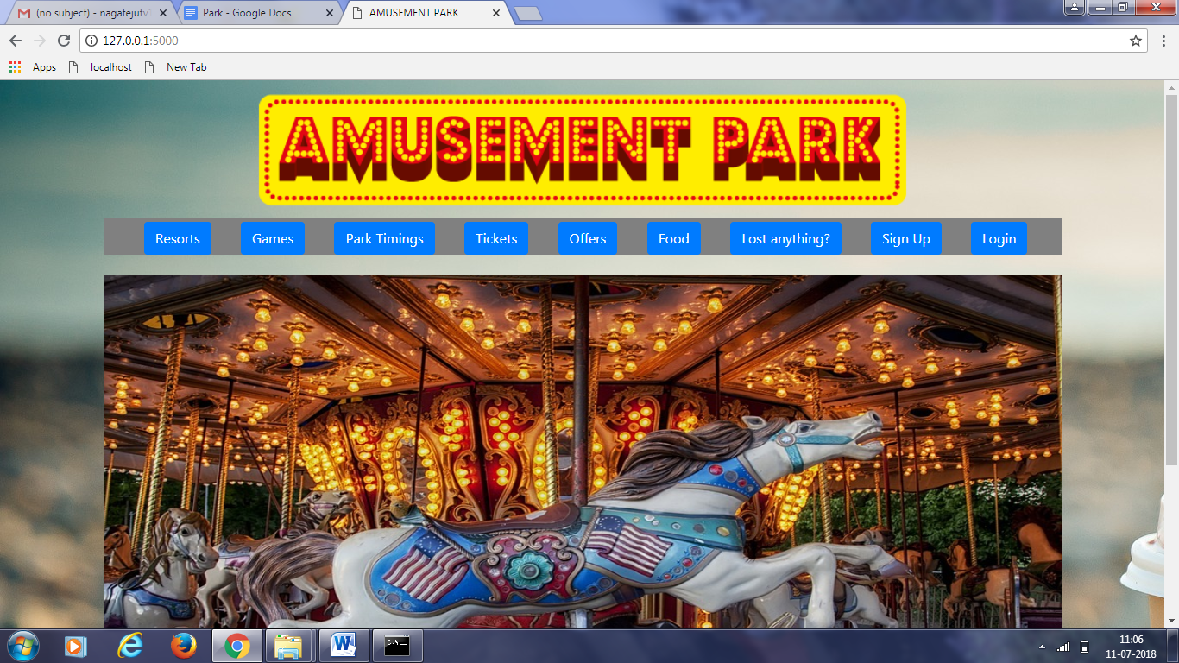

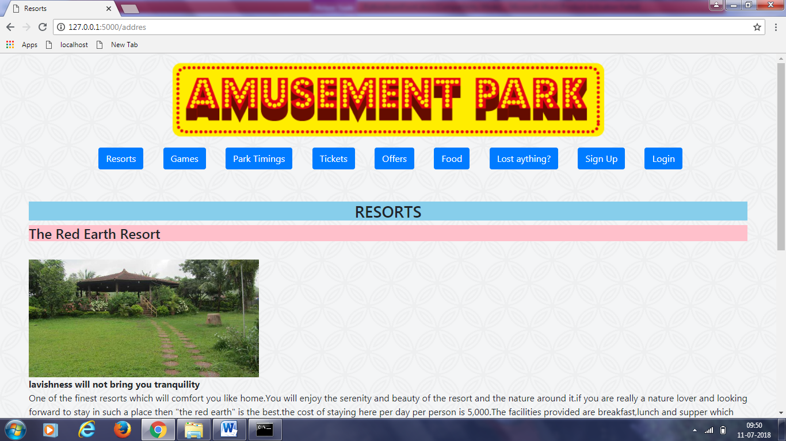

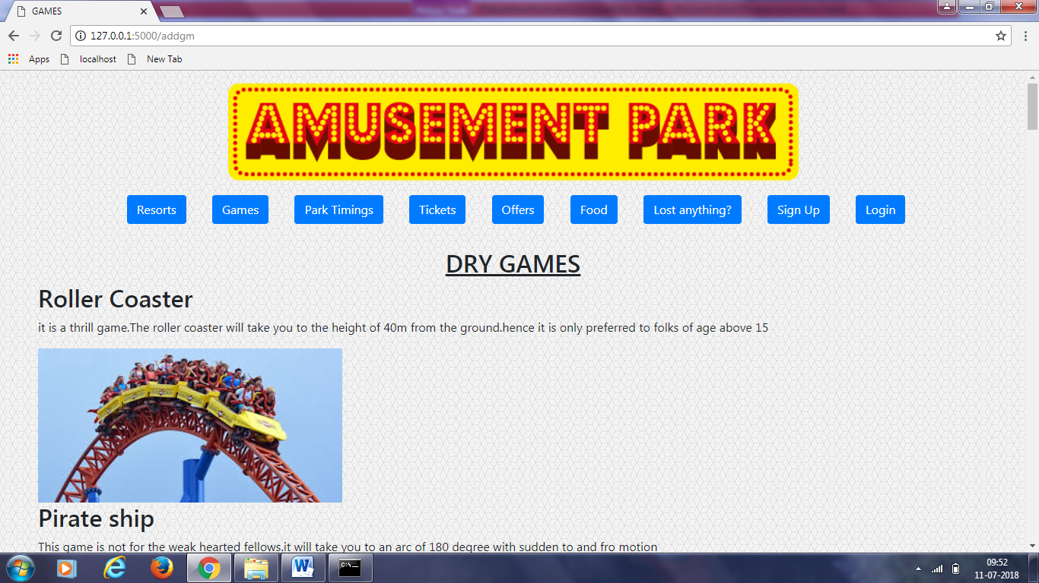

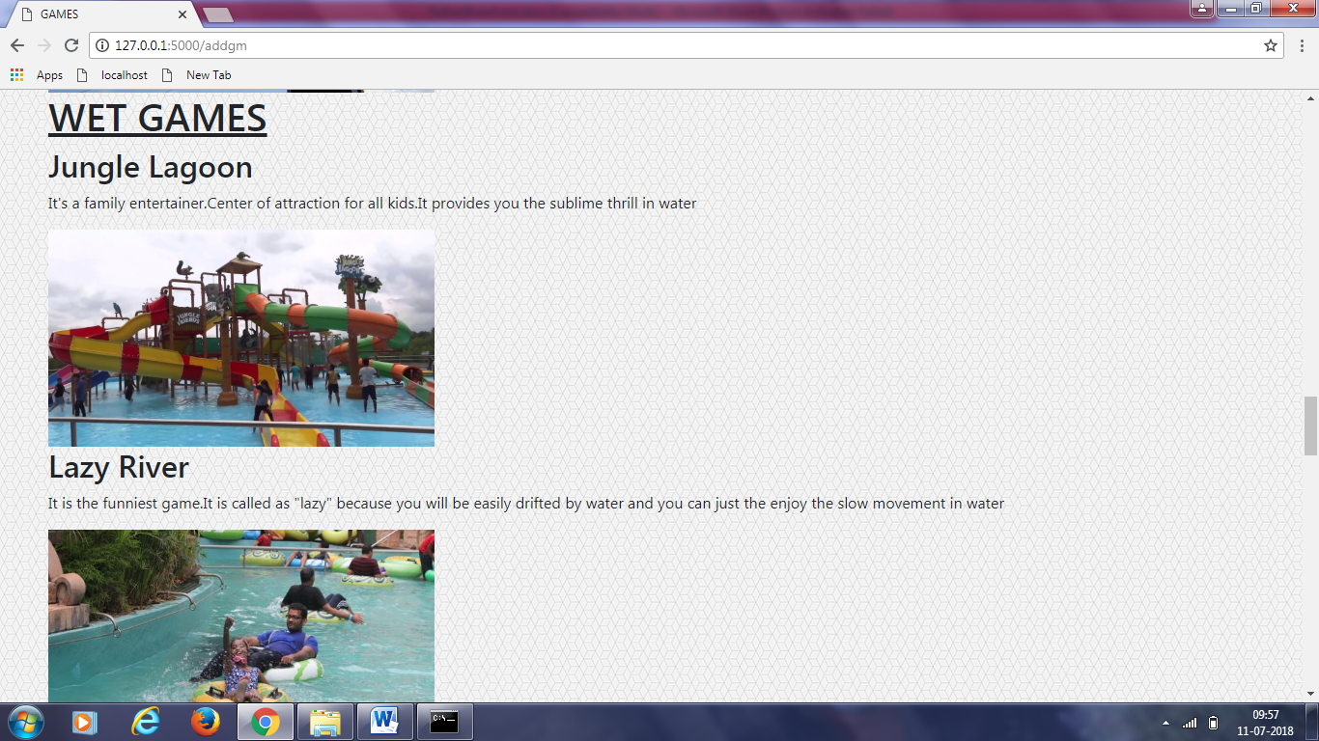

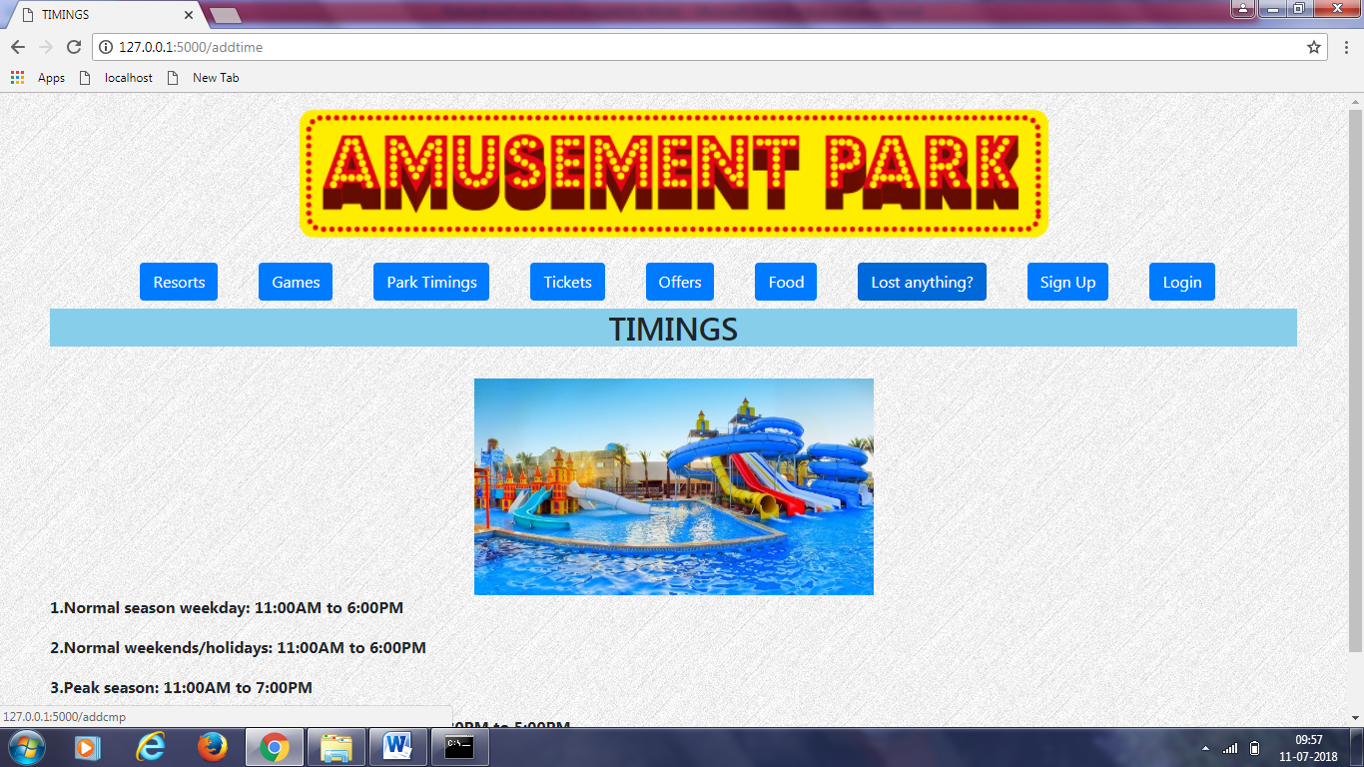

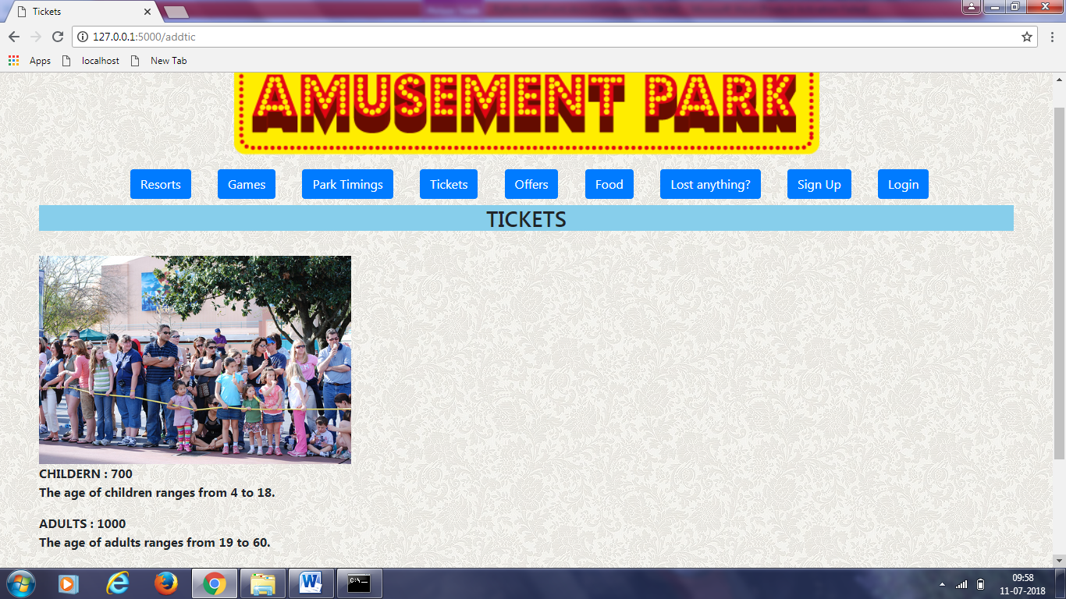

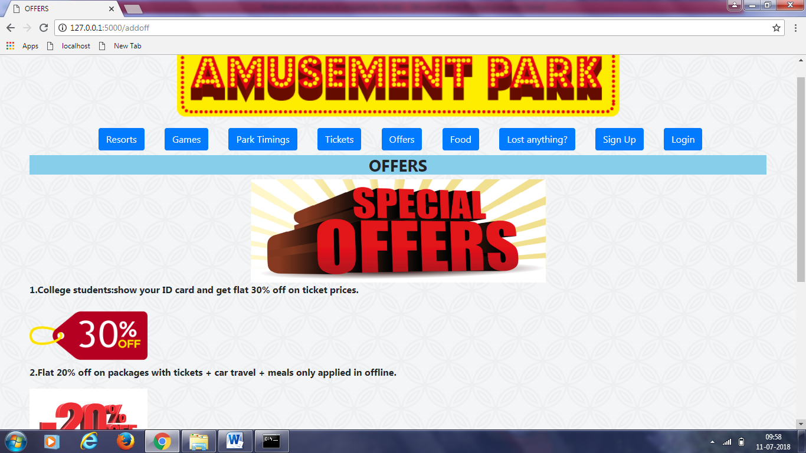

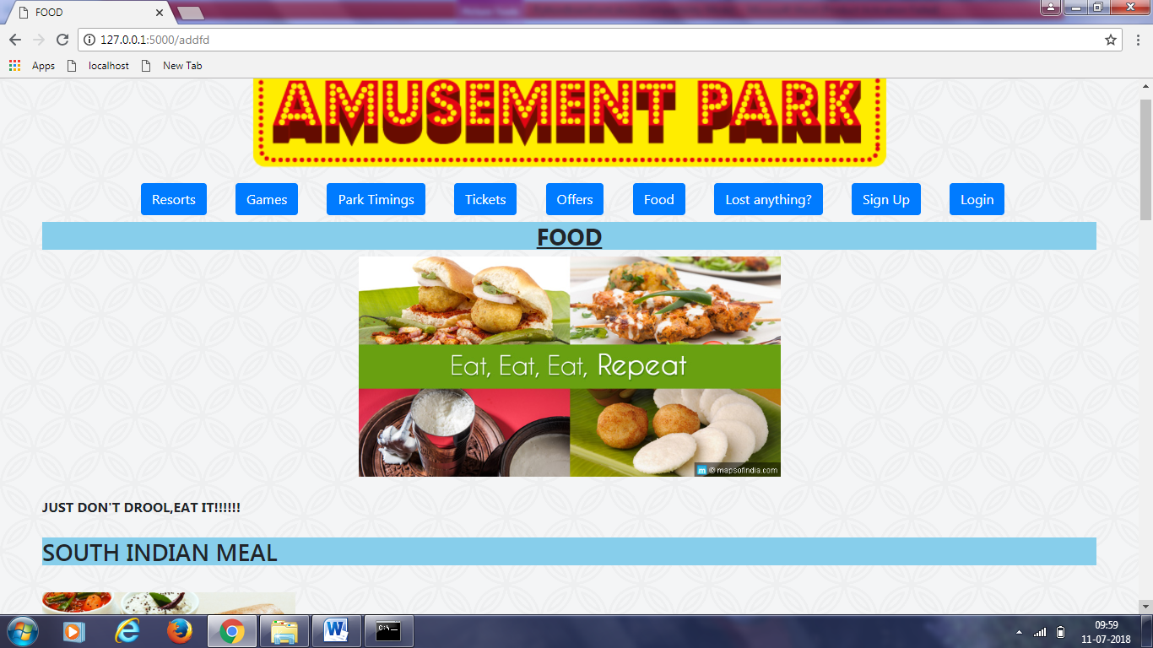

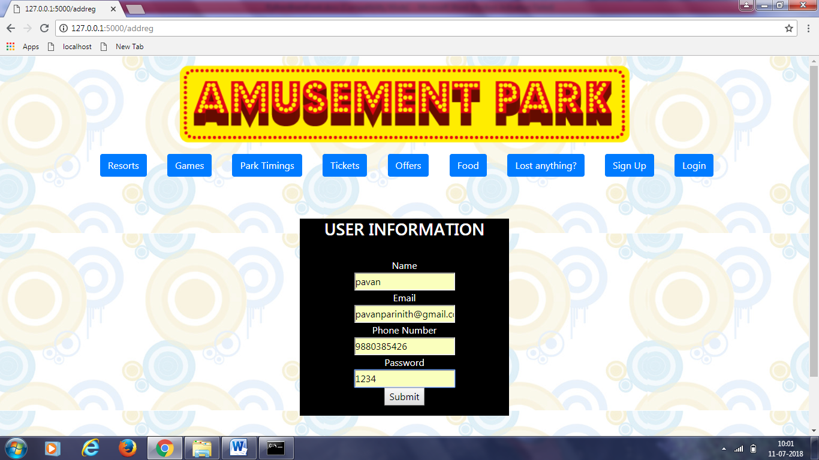

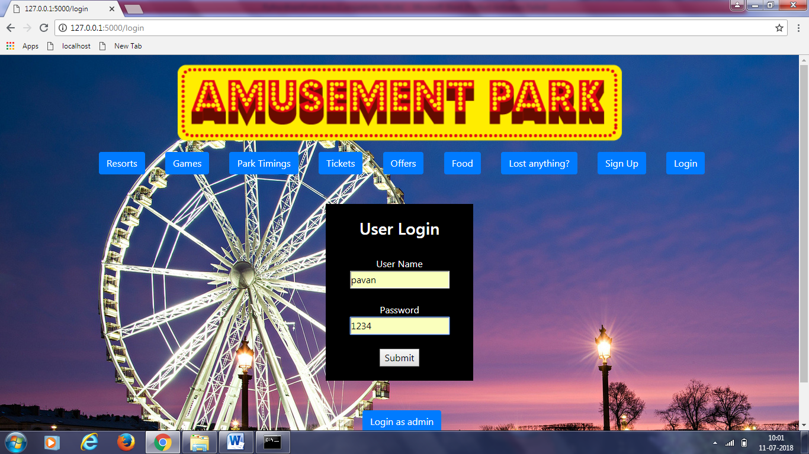

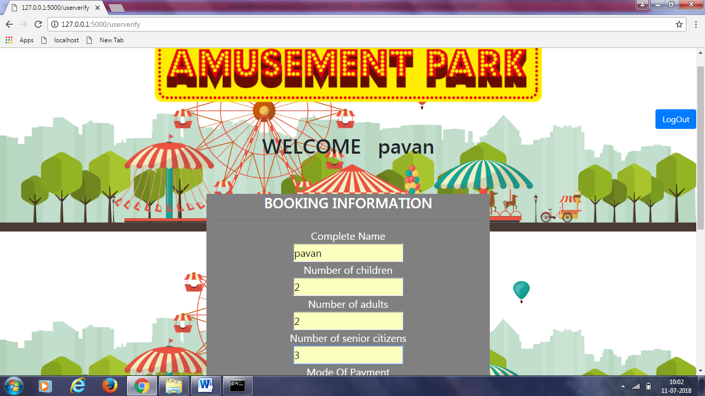

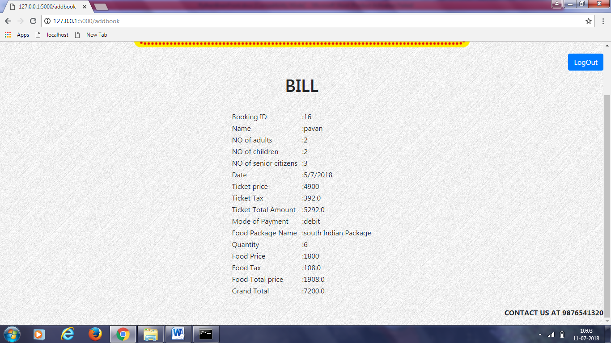

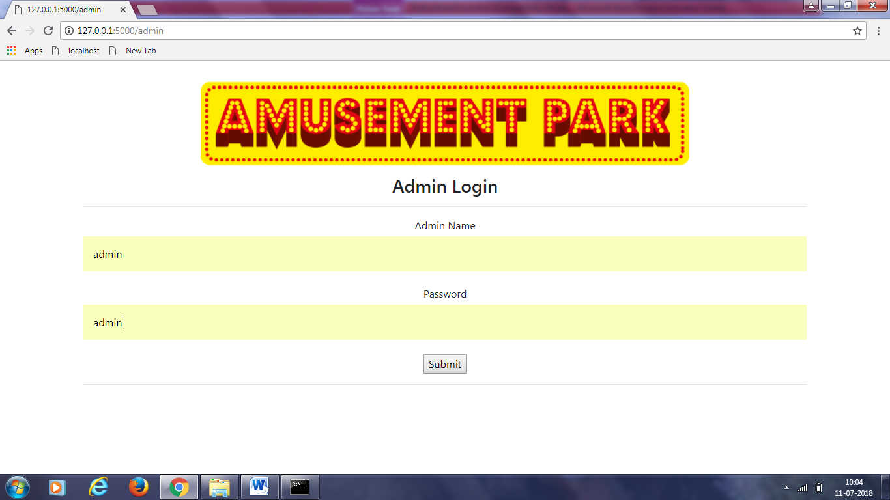

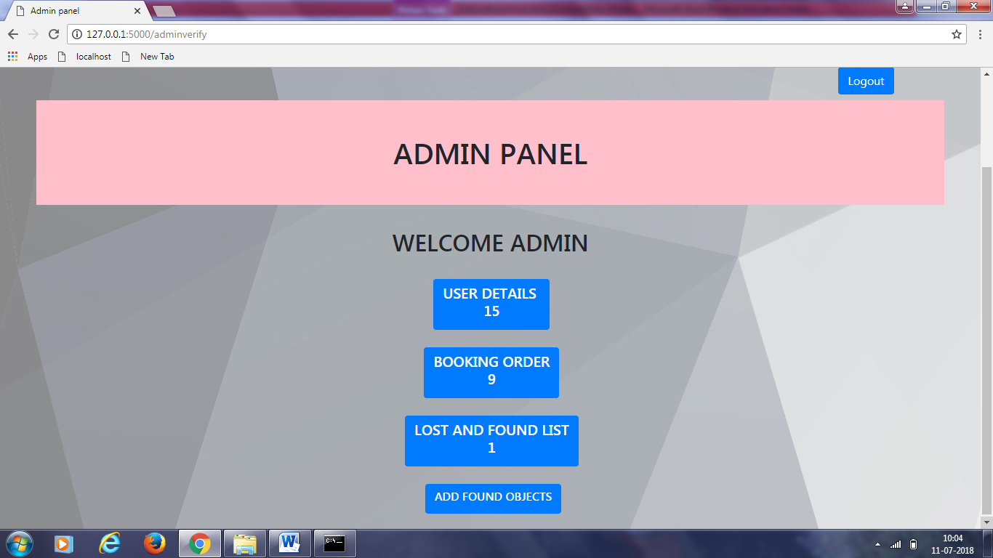

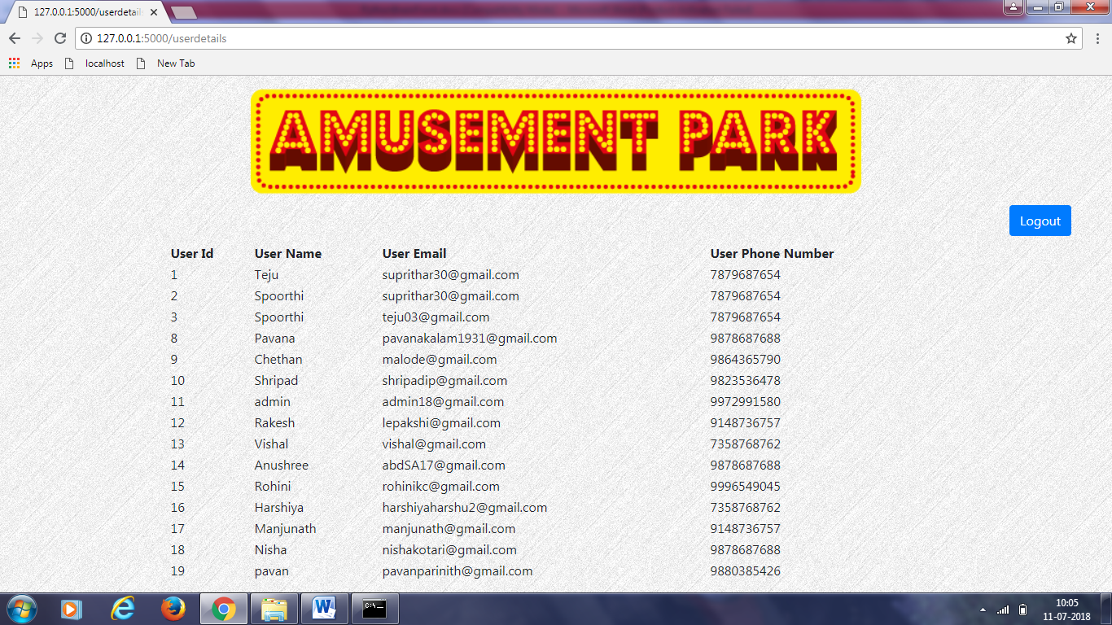

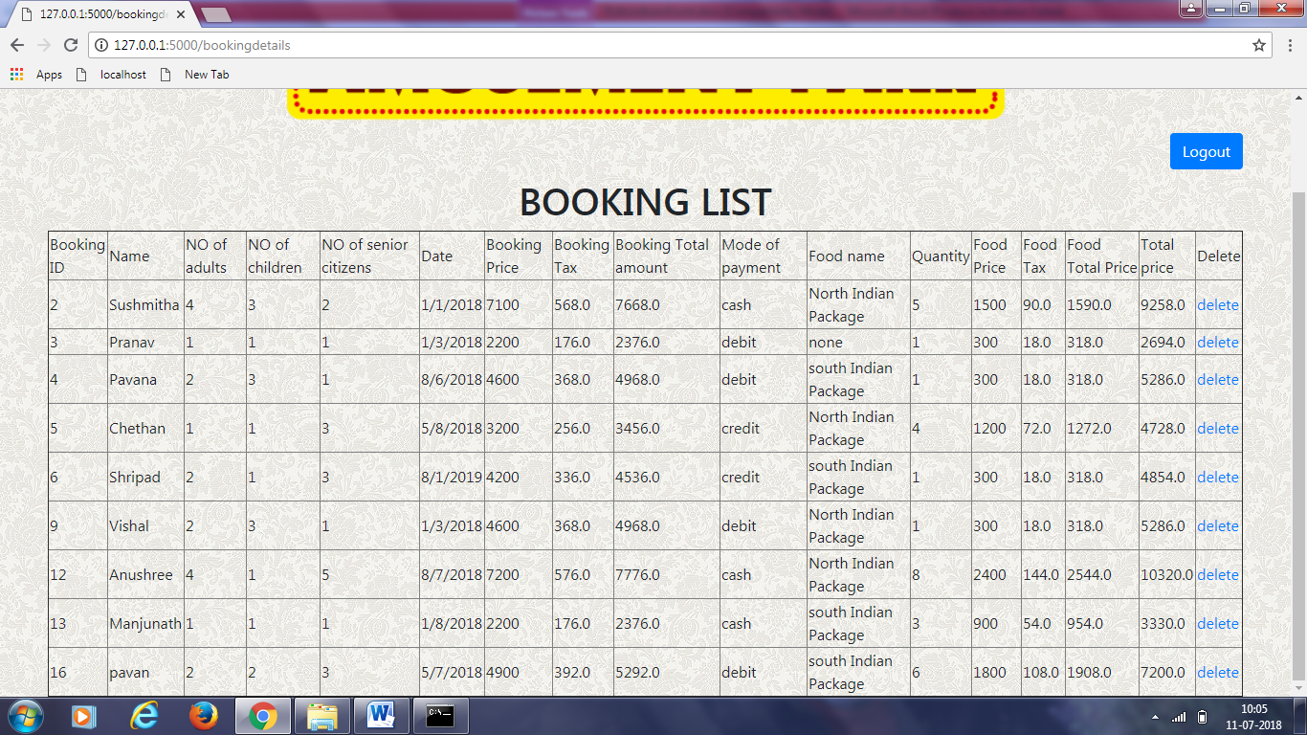

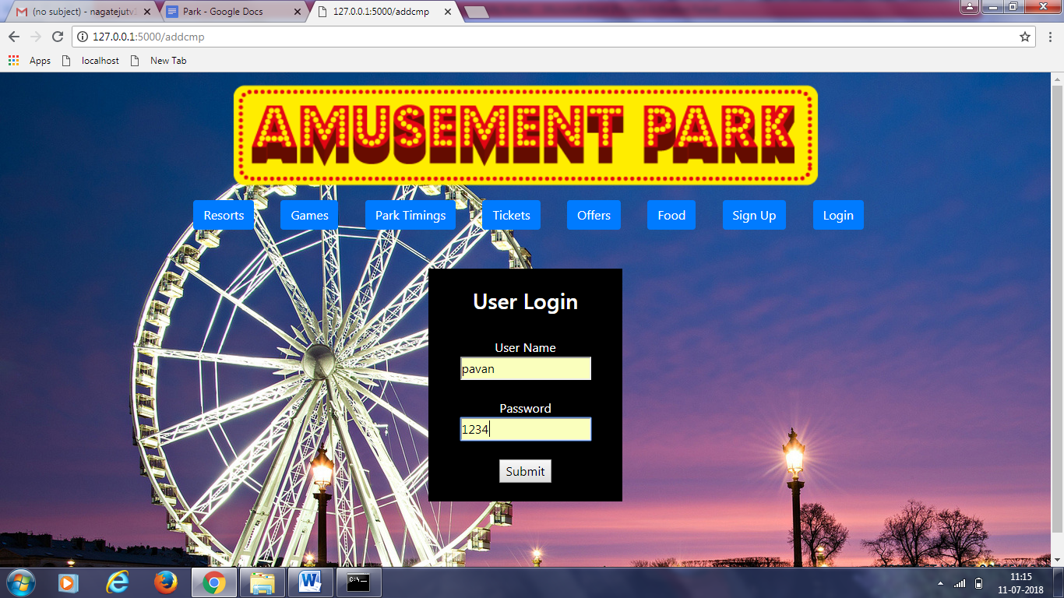

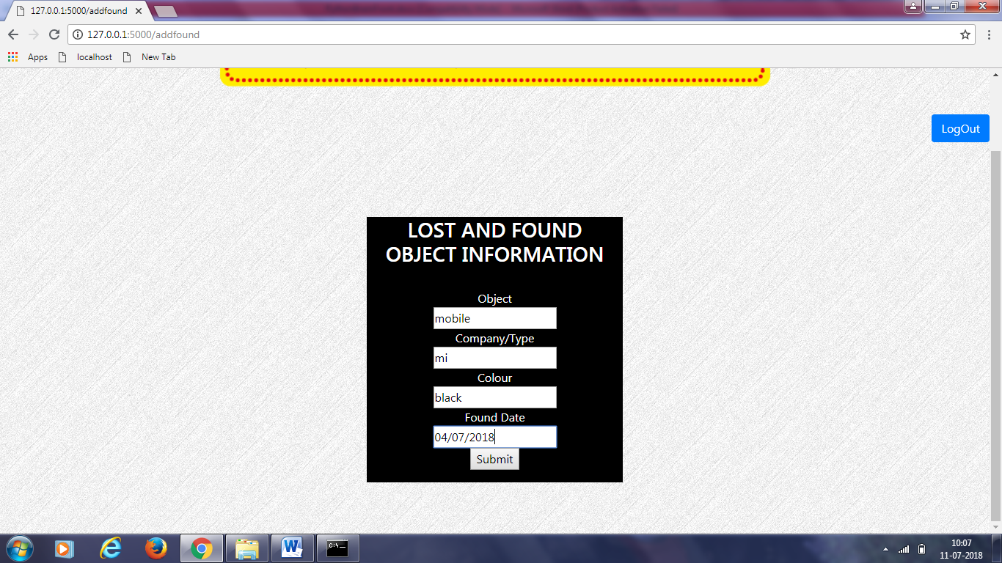

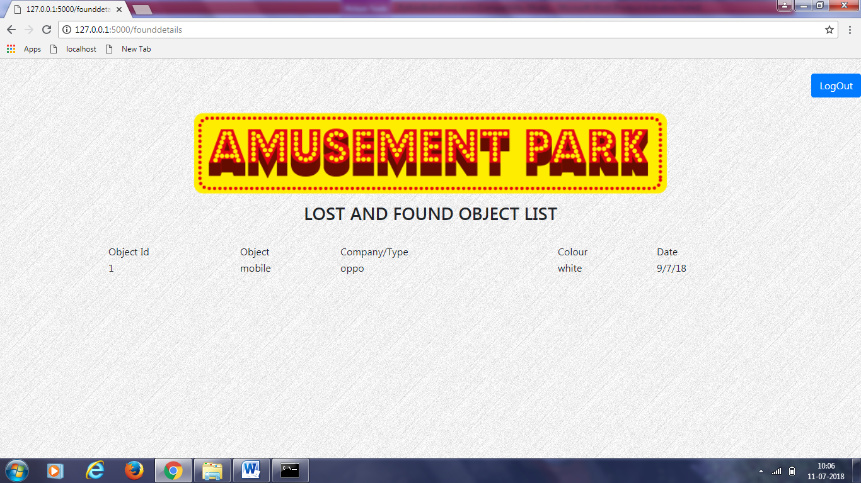

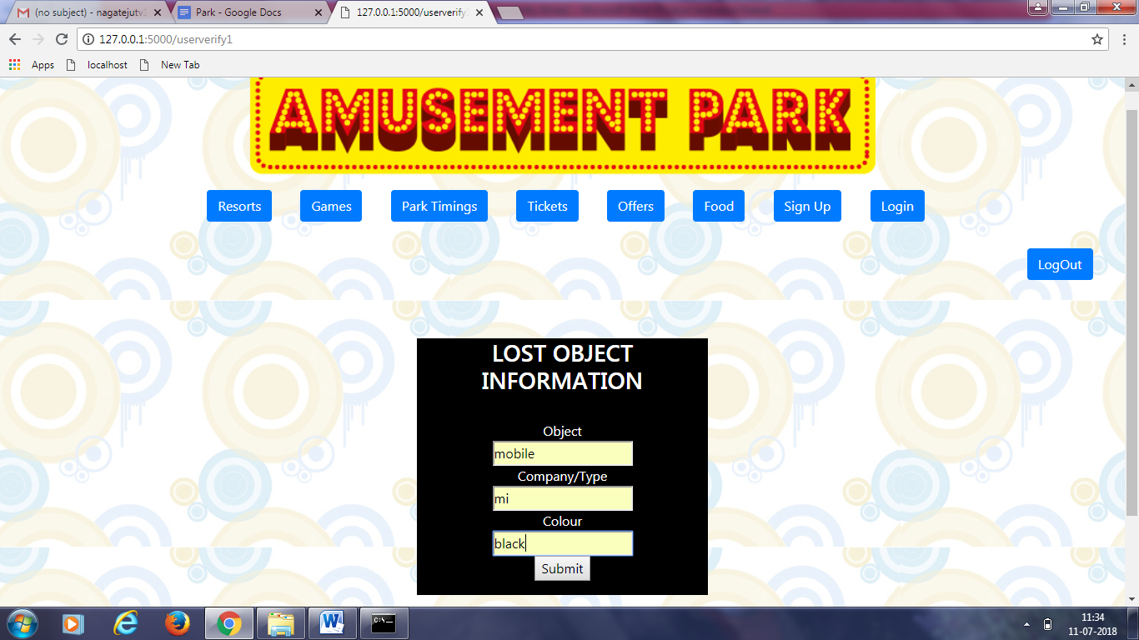

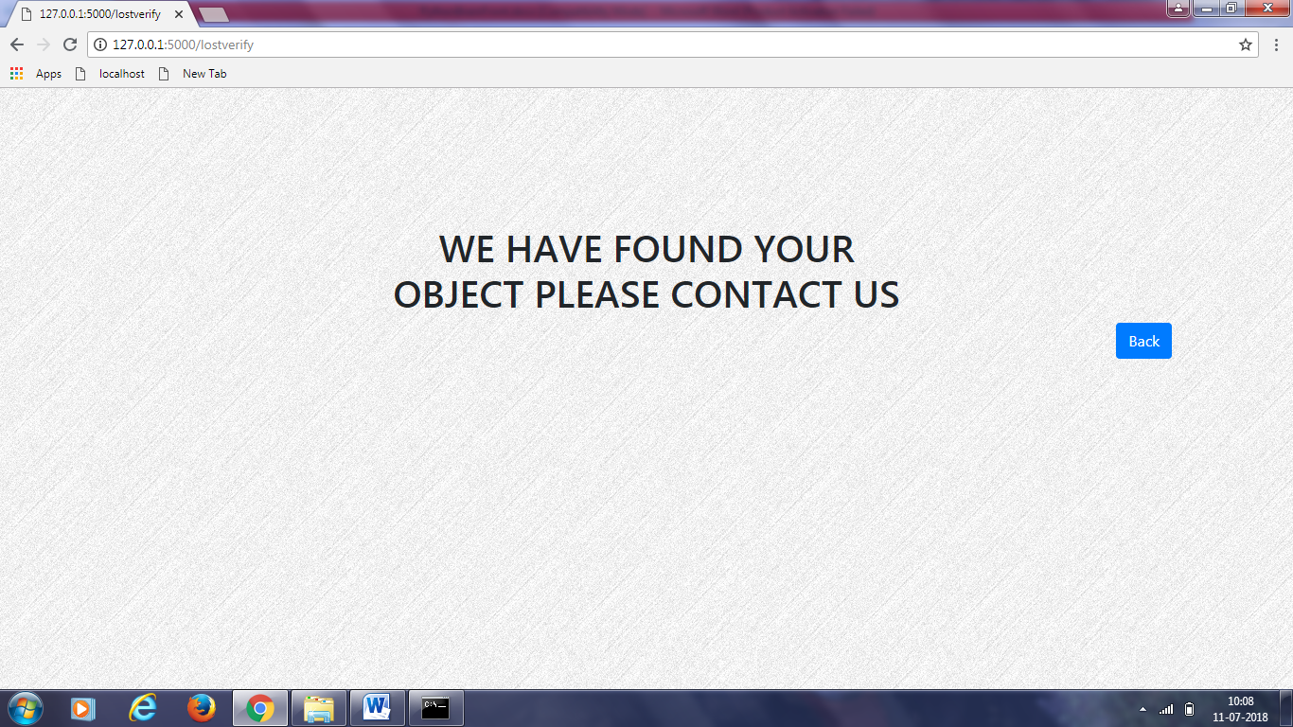

**CONCLUSION**

This project helps the visitors who have not acquainted about amusement park details. The main aim of the project is to give complete details of the park like games, resorts, ticket price, timings of park, food details. Hence it helps the visitors to know about the park completely.

**FUTURE SCOPE**

Amusement park is not only a source of entertainment but also a vibrant source of profit for a country. Rapid economic growth along with evolving of service sector espouses a substantial number of people who have regular income with diversified need. Among those needs entertainment plays a very important role. Because today’speople are very much concern about their mental health. They are aggressively active in entertainment market in order to maintain as well bring something new to their busy and rigid life structure. On the other hand, already structured India theme park sector cannot no longer rely oncentered leading due to immense competition and rapid evolving global market. It needs to be spared throughout the country. In order to earn handsome profit as well as ensure continuous growth, any entertainment sector needs to find new areas for providing service.

REFERENCE

Websites:<https://www.w3schools.com/>php

Websites: https://en.wikipedia.org/wiki/Stack_Overflow